**Ideation Phase**

**Brainstorm & Idea Prioritization**

| Date | 19 May 2023 |
| --- | --- |
| Team ID | NM2023TMID13113 |
| Project Name | Reducing-the-Environmental-Footprint-of-Food-A-Comprehensive-Management-system |
| Maximum Marks | 4 Marks |

Reducing the Environmental Footprint of Food: A Comprehensive Management system

Sustainable Sourcing: Prioritize sourcing practices that focus on local and organic food production, promoting regenerative agriculture, and supporting fair trade practices.

Climate-Smart Farming Techniques: Encourage the adoption of climate-smart farming techniques such as agroforestry, cover cropping, and crop rotation to enhance soil health, conserve water, and reduce greenhouse gas emissions.

Water Conservation: Implement efficient irrigation systems, water-recycling techniques, and water-saving technologies to reduce water consumption in agriculture and food processing.

Renewable Energy Integration: Promote the use of renewable energy sources, such as solar and wind, in farming operations, processing facilities, and transportation logistics.

Food Waste Reduction: Develop strategies to minimize food waste throughout the supply chain, including improved inventory management, optimized packaging, and enhanced distribution systems.

Circular Economy Approaches: Implement circular economy principles, such as food waste composting and anaerobic digestion, to convert organic waste into valuable resources like fertilizers and renewable energy.

Sustainable Packaging Solutions: Prioritize the development and use of sustainable packaging materials, including biodegradable, compostable, and recyclable options, while minimizing overall packaging waste.

Consumer Education and Awareness: Focus on educating consumers about sustainable food choices, portion control, and proper food storage to reduce waste and promote sustainable diets.

Technology and Innovation: Invest in research and development of innovative technologies that enhance resource efficiency, such as precision agriculture, vertical farming, and smart supply chain management systems.

Collaboration and Partnerships: Foster collaborations among stakeholders, including farmers, food producers, retailers, policymakers, and consumers, to develop and implement sustainable food management practices collectively.

It's important to note that the prioritization of these ideas may vary depending on the specific context, regional considerations, available resources, and the level of impact each idea can make.

**Step-1: Team Gathering, Collaboration and Select the Problem Statement**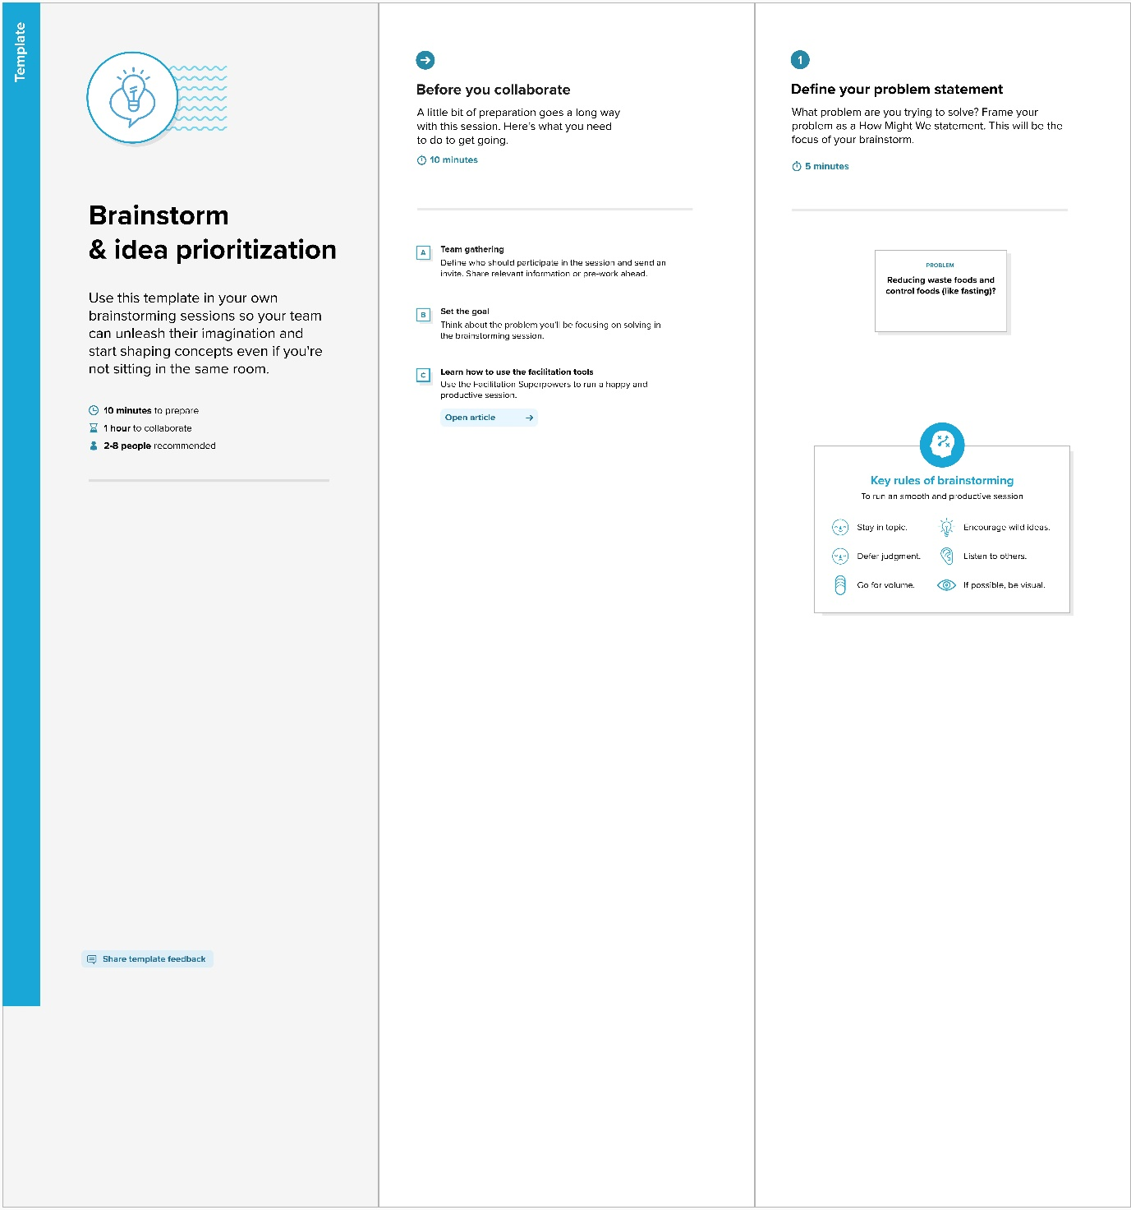

**Step-2: Brainstorm, Idea Listing and Grouping**

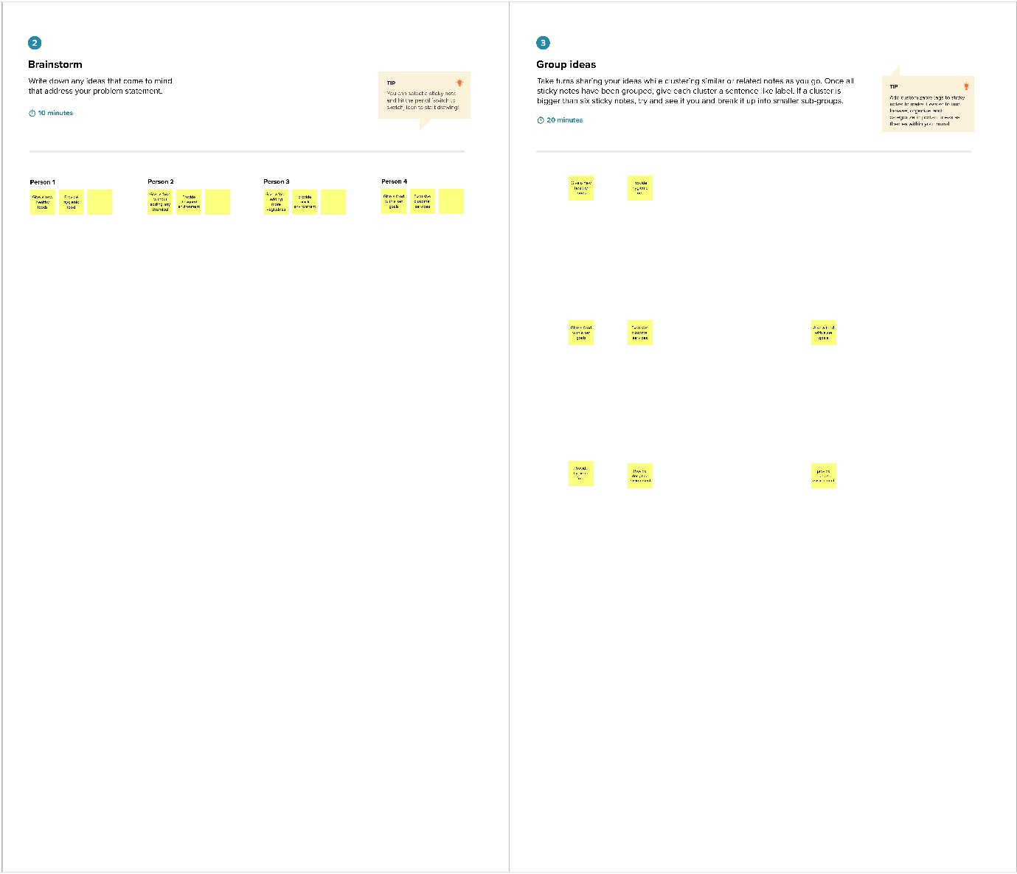

**Step-3: Idea Prioritization**

